Level: 9th form
Date: February 18th 2016
Time: 1 hour
English ordinary test № 2
Jendouba El Jenoubia
Preparatory school
Teacher: Mr. Kileni

Name: ………………………………………….. ...Class: ………………Number: ………

- Listening comprehension :( 8 marks)
- Tick (√) the right alternative (1 mark) The passage is about:
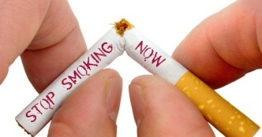
- Pollution
- Smoking
- Organic food
- Listen and say whether the following statement is true or false(1 mark)
- Non –smokers have serious health problems

- Fill in the table below with the right information (2 marks)

Number of smokers who smoke everyday in USA | Number of adults who smoke in the USA

- With reference to the passage ,what are the dangers of smoking ? (1 mark)

---------------------------------------------------------------------------------------------
- Fill in the gaps with words from the listening passage (1 mark)
No matter how long you’ve smoked, ----------------can significantly ---------------- your risk for serious health problems.
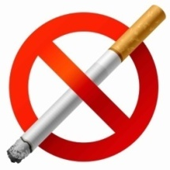
- Tick the right meaning the following word: (1 mark) cause
« risk » danger
Solution
- Listen and say whether the following sounds are similar or different : (1 mark)
lead _ health (--------------) but_adult (--------------)
II) Language (12 marks)

- Circle the correct alternative (3 marks)
More and more people all over the world realize that global warming is a serious problem. Almost everyone agrees that the Earth's (climate/poison/creatures) begins to change, the summers are hotter. The winters are warmer. All governments must (prohibit/punish/take) action with new laws to protect the environment. Individuals can take action too .Here's how:
- Take public transportation like trains and buses, even (best/good/better), if you walk.
- Use less water at home. For example, when you brush your teeth, turn (on/off/in) the water.
- Turn off the (lights/detergents /burns) computer and TV when you're not (used/use/using) them.
- Recycle newspapers, aluminum cans, plastic bottles, and other materials.

- Complete the dialogue with the right utterances from the box (there is one extra utterance) (2,5 mark)
- 1- You may print out your ticket at the kiosk
- 2_ Yes of course. Here you are
- 3- Would you mind showing me your ticket, please?
- 4- mind wasting time
- 5- That’s kind of you
- 6- could you pass me the salt please?

Flight attendant: Good morning. (Polite request)--------------------------------------------------------?
Passenger: (Agreeing) -----------------------------------------------------------------------.
Flight attendant: Oh, you have an e-ticket (possibility) -------------------------------------------------------------------------------.
Passenger: I already printed out my boarding pass at home.
Flight attendant: Would you like a window or an aisle seat?
Passenger: An aisle seat, please.
Flight attendant: Here's your boarding pass. Have a nice flight
Passenger: (thanking) -----------------------------------------------------. Excuse me; is there any place to buy something to drink after the security check point?
Flight attendant: yes, there are kiosks that sell coffee and drinks but (warning) -------------------------------------------------------------the plane is about to take off.
3) Put the words between parenthesis in the right form or tense. (2 marks)
Water pollution becomes a big problem around the world. Many rivers and sea (not / be) --------------------safe to fish in or swim in due to water pollution. Industrial toxic waste which contains (heavily) ---------------------- metals like plastics may kill marine life very (quick) -----------------------These pollutants in the water can cause serious health problems and sometimes even lead to (die) ---------------------------
4) Fill in the gaps with five words in the box. There are two extra words (2.5marks)
safe – area – contamination – endangered – species – offenders – logging
Many tigers are endangered because they 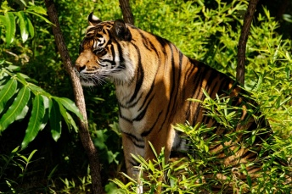 have lost their homes, or habitats. Tiki and other Sumatran tigers live in lowland forests on the island of Sumatra. Sadly, this -------------------------- has one of the highest rates of habitat destruction in the world due to--------------------------activities and rainforest destruction for cheap commodities like paper and palm oil. When Tiki’s habitat gets cut down, it gets harder and harder for him and the other tigers to survive because there is less food to eat, less ------------------------------ places to sleep, and less space to share with all the other animals. Other--------------------------- are threatened and-----------------------------too: Sumatran elephants, orangutans, and even species of plants and trees!
5) Match sentences parts to get a coherent paragraph. Answer in C (2 marks)

A | B | C
1_Online shopping is buying goods and services | A-Buying from malls, over phone or by mail | 1
2-Shoppers can visit web stores | B-they surf the net to chat | 2
3-But people may worry about shopping online because | C-they fear that credit information will not remain private | 3
4- other ways of shopping are | D-As they sit in front of their computers | 4
 | E- through the Internet

